The Third Man
A man prepares to get out of a railway carriage. He stares expectantly up the platform. Smoke from the train rises, obscuring him. He steps into the smoke.
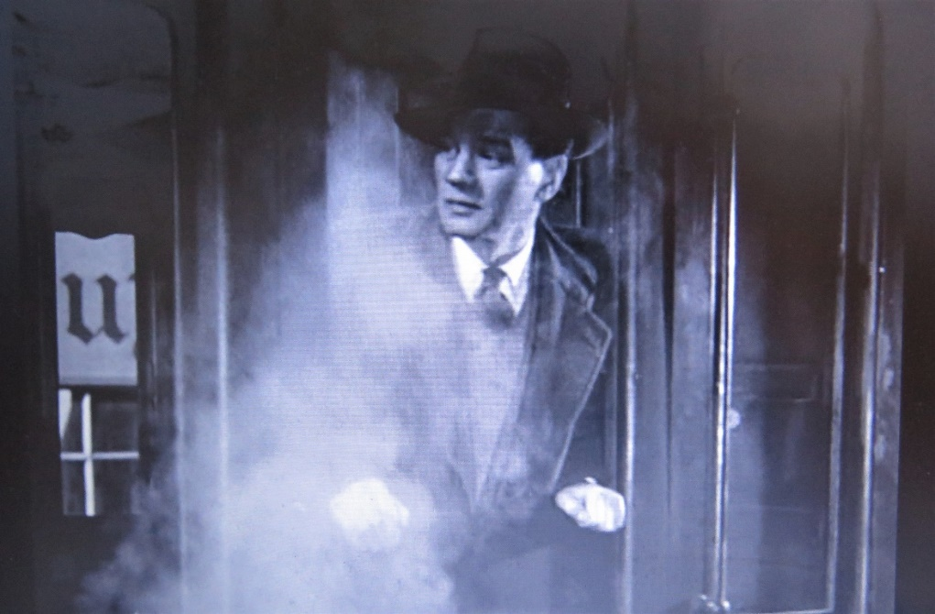 (02.58)
The same man, later we will know him to be Holly Martins, seeks out the friend who was meant to meet him at the station. As he approaches the friend’s apartment, its entrance flanked by imposing, almost theatrical statues, he casually passes under a ladder. Blink and you can miss both the steam/smoke and the ladder incident, but there they are and both are perfectly innocuous. In this symbol-rich film, as should be the case with a work of art, nothing makes it into a shot without deliberate inclusion. Both moments are also highly suggestive of the deceptive world that Martins is entering and the already blighted fortune he faces in his innocent pursuit of truth about his friend Harry Lime’s supposed fatal road accident and the number of people who may or may not have been present when he died.
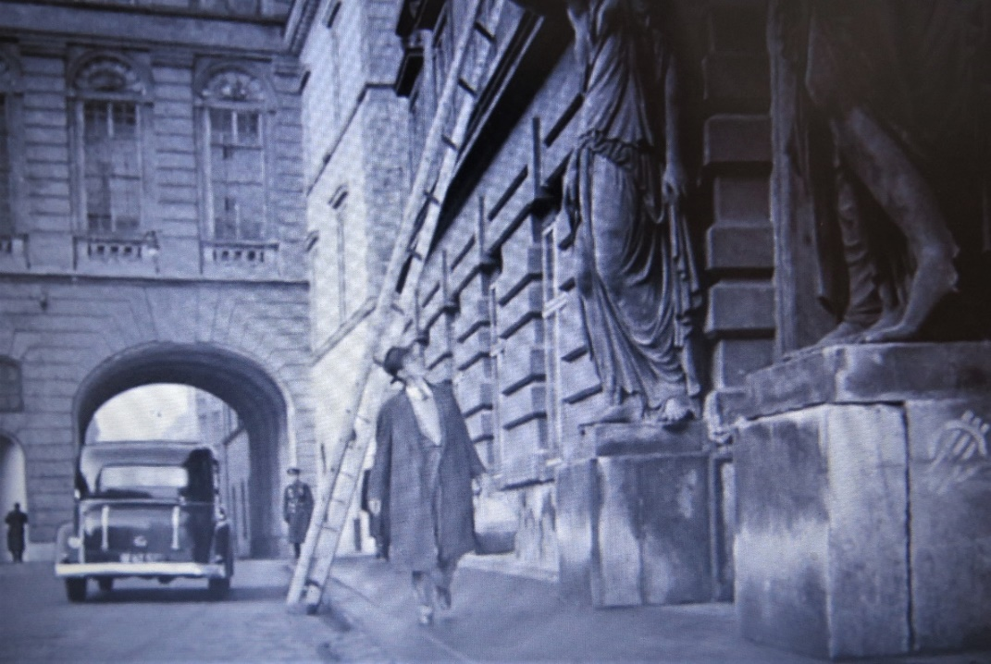 (03.22)
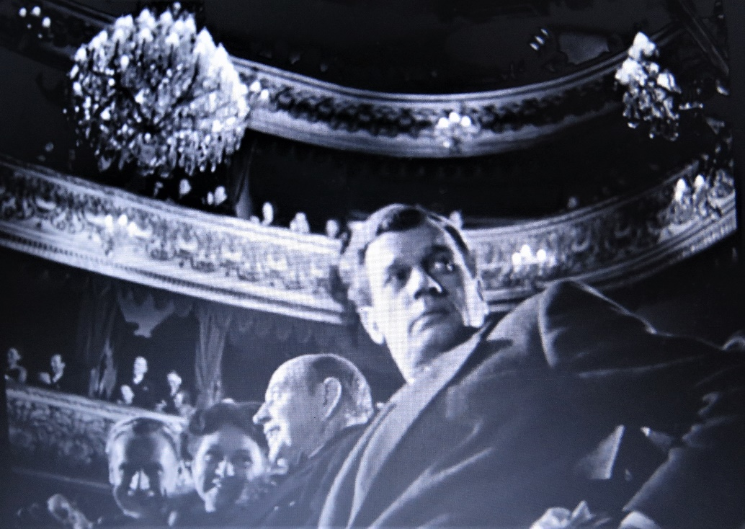
There is a story that the film director William Wellman sent The Third Man’s director Carol Reed a spirit level suggesting that next time he made a movie he should put it on the camera to ensure it was straight. The Third Man is full of off-kilter shots - such as the one above of Holly leaving his theatre seat to seek out Anna for the first time. Of course, such shots were not accidents or mistakes, they were deliberate, and again they suggest something about the world that Holly Martins is entering and the clarity of his perception of what id going on as he seeks the truth.
Carol Reed’s 1949 masterpiece, The Third Man, is often included in lists of the top ten British films ever. It is a thriller but at the same time it explores the issue of moral choices. In places it is funny and witty. Perhaps because the film deals with so many different themes and genres it is difficult to classify. As you work through this guide you’ll be asked a number of questions which hopefully will help you come to your own decisions about the film.

Activity 1: The Trailer – Expectations
There are at least two versions of the original 1950 trailer for the film online. This link takes you to the longer of the two: The Third Man Theatrical Trailer HD - YouTube
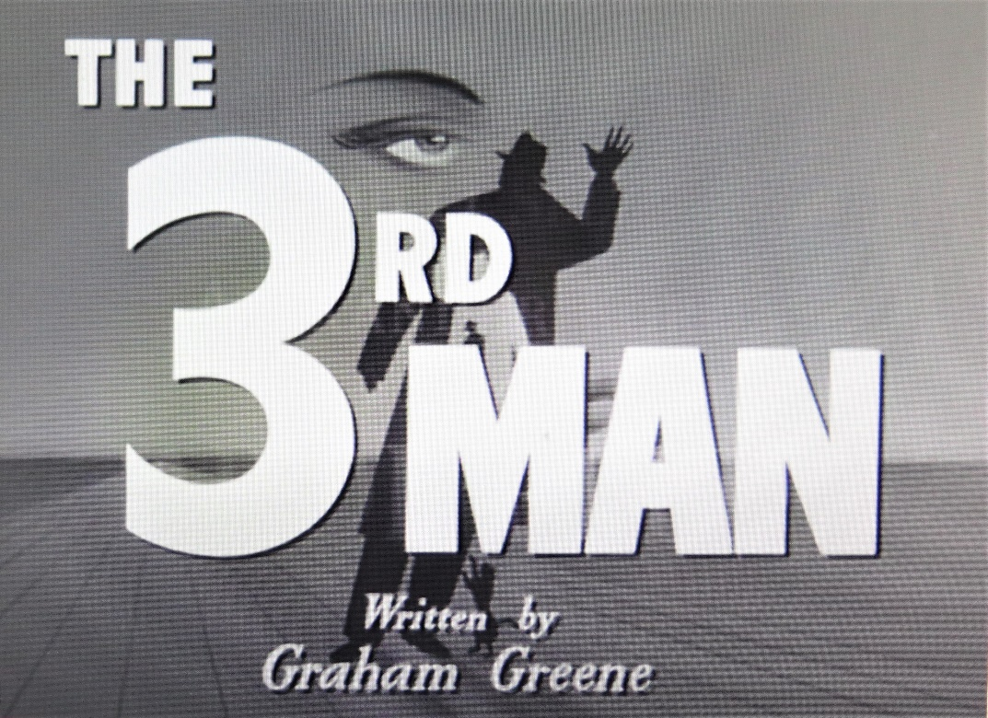
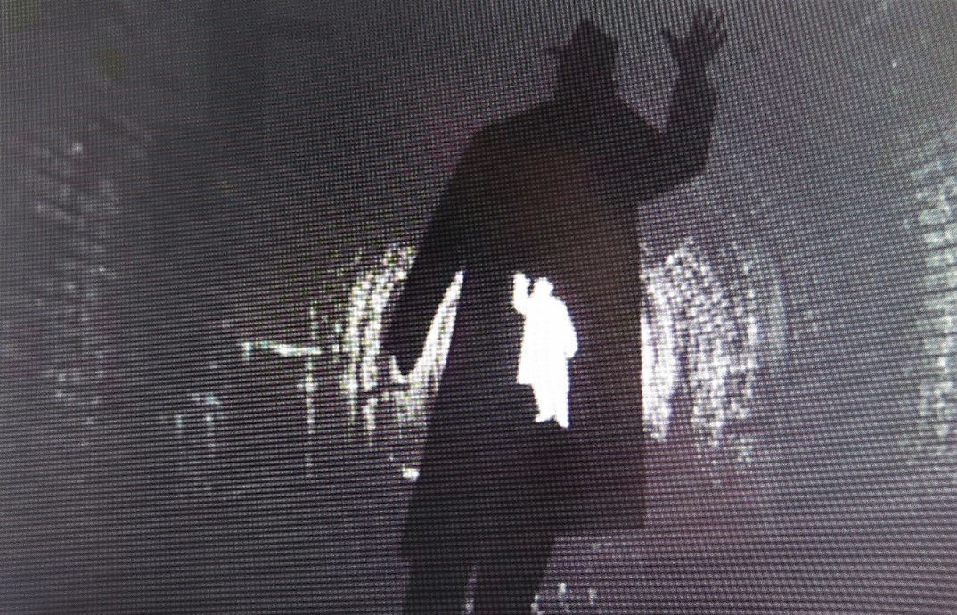
This is the script:
Male Voice: The 3rd Man….hated by 100 men
Female Voice: Desired by one woman…
Male Voice: The 3rd Man…hanging is too good for him.
Female Voice: Nothing is too good for the Third Man. Her man was the 3rd Man. The man on every woman’s lips.
Caption celebrates the Anton Karas soundtrack: “He’ll have you in a dither with his zither”
Male Voice: Vienna, 1950… a city fearful of its present; uncertain of its future.
Vienna: the once gay capital of a light-hearted people. Here in the shadows of its palaces and ruins, is told, with tenderness, drama and suspense….
The Story of the 3rd Man.
The 3rd Man: a story of two men and one woman caught is the dangerous web of an international love-affair.
Two scenes from the film… Trevor Howard’s character Major Calloway condemning Harry Lime followed by scene in which Joseph Cotton declares his love to Valli.
Male Voice: The 3rd Man: Joseph Cotton in his most successful performance as an American caught in a whirlpool of continental intrigue. The glamorous Valli as the mysterious actress who knew the secret of the 3rd Man.
The 3rd Man.
Watch the trailer and try to work out how it tries to ‘place’ the film in terms of its genre and its possible audience – age/gender.

There are lots of ways to persuade people to do or buy things. Study the following list and discuss which of the ‘hooks’ are employed in this earlier Third Man trailer.

- Anger
- Familiarity – a tried and tested formula or franchise; the next part of a story or series (franchise).
- The desire to be diverted or amused – escapism. The desire to explore a fantastic world or be witness to exciting events.
- You might miss out
- Watch it on a big screen in a cinema rather than via a streaming service
- Authenticity
- By-passes or pushes the rules on censorship or public taste
- Zeitgeist – what was happening in the world at the time/what people were concerned with at the time.
- Exotic locations or people
- Historic events brought to life
- A story experienced in a different context brought to life on the screen (a novel; a TV-show; a video-game; even a theme-park ride)
- Curiosity
- Endurance – this film will really put you through something
- Empathy – understanding things from a very different point-of-view
- Romance/Love
- The sexual attractiveness of a male or female star
- The acting ability of a male or female lead
- The desire to be horrified or shocked
- Education – you’ll learn something by seeing this film.
- Soundtrack/Music

Anything else?

Use the list to explore the promises being made by other film trailers.

Now look at a more recent trailer for the film – created when The Third Man was released in a new digitally restored form in 2019 – the 70th anniversary of its being made. Compare it to the original trailer.

THE THIRD MAN - Official Trailer - Directed by Carol Reed - YouTube
Things to watch out for:
- The overall celebration of the new restored print of the film and its Oscar-winning cinematography (the work of Robert Krasker).
- The soundtrack in which there is still a lot of reliance on the Karas zither music but also other sound elements are included which might be said to be representative of the film.
- The change in tone and tempo of the new trailer now the film is considered a ‘classic’. In what way do you feel the new trailer treats the film with greater respect than the original one, when the film was still new to audiences.
- Stylistic changes between older trailers and new ones – the lack of a voice-over, for example.
- Anything else?
Once you have seen the film, go back to the trailers, both the old one and the 2019 promotion, and examine how the makers have constructed the narratives from images and sequences often far removed from their actual meaning within the film. One of the best examples is perhaps the lone girl in the near-empty nightclub performing a forlorn dance wearing next to nothing.
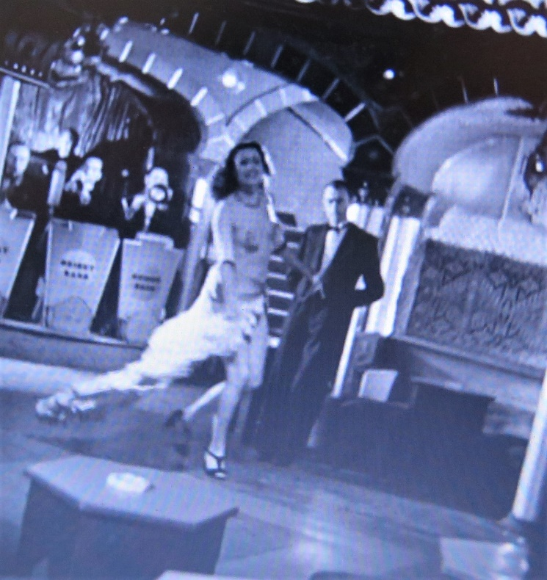 (58.59)
To my mind, she represents a kind of bottom-of-the barrel, world-weary entertainment that goes with the battered city and its exhausted care-worn inhabitants but notice how the original trailer tries to make the sequence exotic with the line: ‘Vienna: the once gay capital of a light-hearted people.’ Yes, the line is nostalgic but it’s likely this ‘moment’ is included to suggest the film is far more risqué than it really is: an example of censor-testing European cinema - sophisticated and erotic. The Third Man contains much but cheap titillation is not one of the ingredients.
Activity 2: The Montage
What do we mean by the term “montage”? One of the most comprehensive discussions of this editing technique can be found at: What is a Montage? Definition, Examples & 6 Ways to Use Them (studiobinder.com). According to the site’s writer Kyle Deguzman, montage can be used to achieve any or all of the following: speed up time; add comedic effect; build character quickly; establish the surrounding context of a story by providing a series of snapshots; tell multiple stories in parallel and, perhaps the trickiest, create meanings by placing images or sequences next to each other. Deguzman’s site discusses the legacy of the Russian filmmaker Lev Kulesho: The Kuleshov Effect Explained (and How Spielberg Subverts it) (studiobinder.com). It is essential for your film general knowledge to follow that link and watch the way Kuleshov demonstrated how emotions can be manipulated through the juxtaposition of different images thanks to our human bias towards creating narratives and seeing patterns.
It was the American producer of The Third Man David O. Selznick who insisted on there being a fuller explanation of the strange administrative arrangements applying to the Vienna of 1949. (Austria and its capital would only gain full independence outside of the Soviet Block in 1955.) It was a felicitous (fortunate) intervention, not least because of the intriguing voiced-over script that accompanies the rapid sequence of shots that make up the montage: 28 shots in 66 seconds.
This is the non-US version of the introduction spoken by the director Carol Reed:
Opening narrator: I never knew the old Vienna before the war with its Strauss music, its glamour and easy charm. Constantinople suited me better.
[Scenes of black market goods changing hands]
I really got to know it in the classic period of the black market. We'd run anything if people wanted it enough and had the money to pay. Of course, a situation like that does tempt amateurs…
[Dead body seen floating in the river]
….but, well, you know, they can't stay the course like a professional.
Now the city is divided into four zones, you know, each occupied by a power: the American, the British, the Russian and the French. But the centre of the city, that's international policed by an international patrol. One member of each of the four powers. Wonderful! What a hope they had! All strangers to the place and none of them could speak the same language. Except a sort of smattering of German.
Good fellows on the whole, did their best you know. Vienna doesn't really look any worse than a lot of other European cities. Bombed about a bit.
Oh, I was going to tell you, wait, I was going to tell you about Holly Martins, an American. Came all the way here to visit a friend of his. The name was Lime, Harry Lime. Now Martins was broke and Lime had offered him, some sort, I don't know, some sort of job.
Anyway, there he was, poor chap. Happy as a lark and without a cent.

Who is speaking this introduction? The line ‘We’d run anything if people wanted it enough and had the money to pay…’ is suggestive of who the narrator might be.
What is the tone of this short exposition? Select the words that best suit it from this list and match your selections to parts of the script to prove your choice(s):
Sophisticated
World-weary
Cynical
Angry
Polemical
Amused
Bitter
Humourous
Matter-of-fact
Detached
(Several may apply.)

And finally, turn off the sound and watch the montage several times and try to write your own, more upbeat version of the opening script – ‘order v chaos’. Try to write the script that would be needed if you were writing a history documentary, or a documentary about the dangers of visiting post-War Vienna.
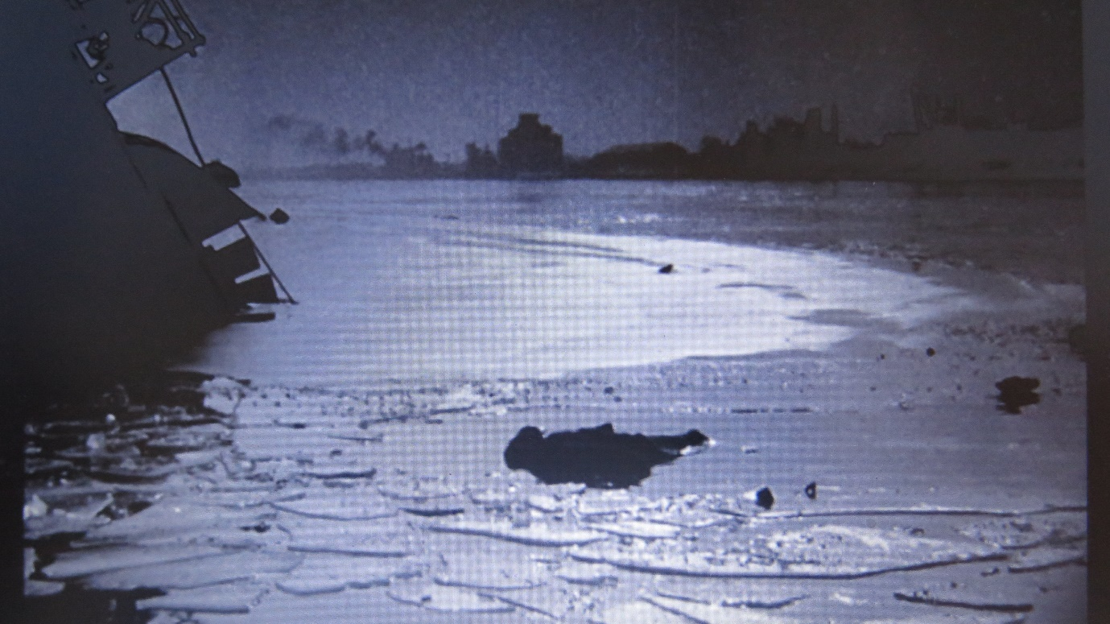
The fate of black market ‘amateurs’ – 02.09 mins

Activity 3. Is The Third Man A Film Noir?
The Third Man is often described as a film noir. It certainly shares some of the characteristics of films that fit the category but in many ways it does not. What is helpful here, is that an exercise that tries to match The Third Man with typical noir themes and motifs is likely to lead to a better understanding of the film. That’s the hope.
But first - what is film noir?

Whether or not noirs are a distinct genre or merely a set of random films linked by a certain stylistic characteristics is a debate that has long-exercised film critics. Certainly, many of the directors who made these films were not aware they were making noirs. The term is the creation of a group of French critics who came across many of these hard-boiled thrillers in the 1950s, for the first time, having been prevented from seeing them during the war. The directors themselves were merely creating stories and making the best they could of limited budgets and sometimes rather second-rate actors. Under these circumstances it made sense to set up clever lighting effects and rather stylised scenes which removed the need for lots of repositioning of the camera (set-ups). Often these directors were émigrés – European Jews fleeing Nazism - who brought with them a kind of ‘expressionistic’ style to lighting and composition that was in complete contrast to the brightly lit and glamorous look of standard Hollywood productions.

All that apart, here is a far from comprehensive list of some key noir characteristics. Your job is to argue to what extent they fit The Third Man or not. Your arguments against are as important as those that make the case for the film being a noir. Things you should consider will be offered and you will be invited to look for patterns in terms of the script and images that you might not have noticed at first. The hope is that you will start to discover how rich and carefully shaped a film The Third Man actually is.

Outlook/philosophy
The noir landscape is invariably a bleak one, populated by low-life characters – thieves, gangsters, murderers and dangerous, scheming women. We will look at the typical noir female characters later, but for now, do you feel the world of The Third Man is unremittingly dark?
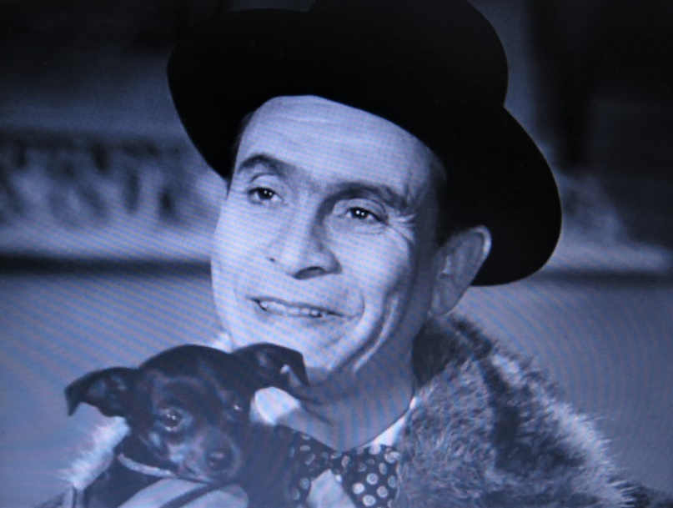
One of the sinister characters Holly Martins encounters while searching for the ‘truth’: Baron Kurtz played by Ernst Deutch. Seemingly charming, his expression can change to a terrible, murderous scowl. (Shown here during his first meeting with Holly - 11.40 mins approx.) He is also (inadvertently) a ‘giver of clues’ – providing the information that takes Holly to Anna and muddling the story of Harry Lime’s death in a way that raises Holly’s suspicions.

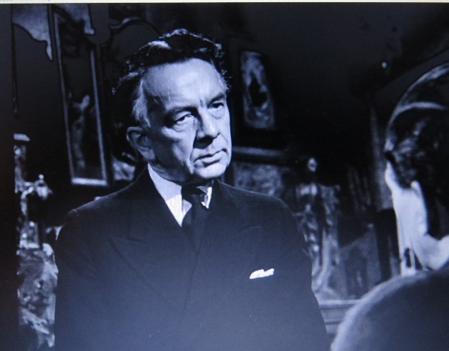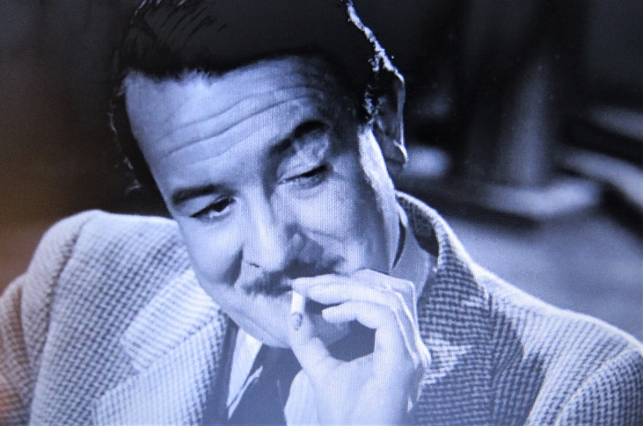
(Left: Erich Ponto as Dr Winkel, and (right) Siegfried Breuer as Popescu)
Use the captioned image as a template above to create a rogues’ gallery of the adversaries Holly Martins encounters as he investigates Harry Lime’s death. They are all what can be called ‘gate-keepers’: there to block the path of the ‘hero’ as he pursues his quest. Eventually, they show their true colours: murdering the porter and terrorising Holly. At which point they switch from ‘gate-keepers’ to overt ‘antagonists’. In your captions do mention the ways in which their accounts of the accident outside Harry Lime’s apartment differ and other ways in which their contribute to Holly’s suspicions.

Are there no chinks of light or hope to offset the cynicism, self-interest and ruthlessness that certainly looms large in the film?

Are there any wholesome characters – or is everyone compromised? To what extent Trevor Howard’s Major Calloway be considered a force for good in the film? He may be pursuing Harry Lime but what about his part in the fate of Valli’s Anna Schmidt character? Are Paul Hoerbiger’s Karl the porter and Bernard Lee’s Sergeant Paine the film’s only true ‘heroes’ and how do they end up? What do their fates say something about the world of The Third Man?

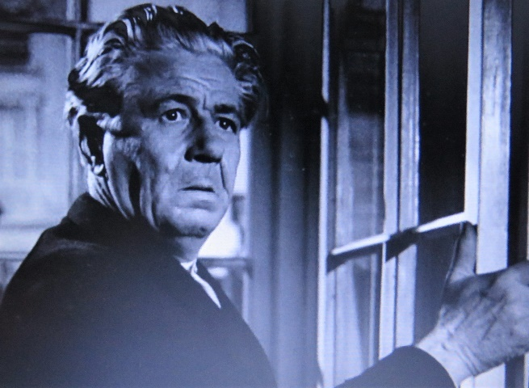

In film noir’there is a strong sense that shadows and gloom are threatening to overcome what light there is – but is that the case in The Third Man? Can you spot any motifs that suggest light might ultimately triumph over the darkness? Study the following moments in which light is alluded to or plays a crucial part in the film. Try to provide captions to the images that highlight how they might relate to this theme?
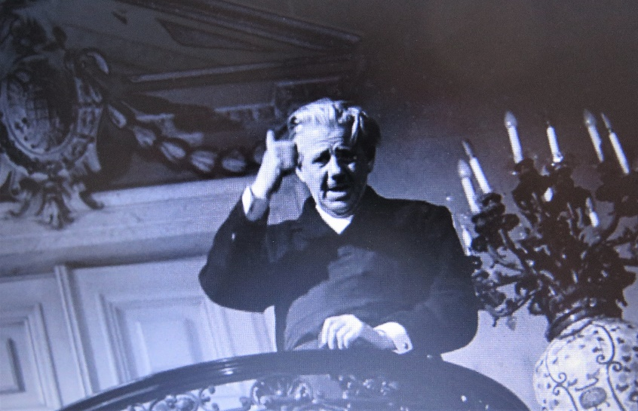
(Caption 1: Karl the Porter of Harry Lime’s apartment block – the job he is doing immediately before this shot has a bearing on the light/dark theme. Also note the mistake he makes about heaven and hell. Is this significant in a film about moral values and the pursuit of truth? 04.27 minutes.)

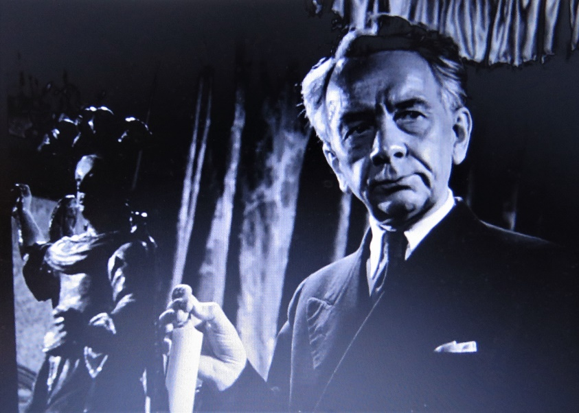
(Caption 2: Dr Winkel plays with an unlit candle as he is questioned by Holly Martins about the numbers of people present when Harry Lime was run over– what could be the significance of this shot?)

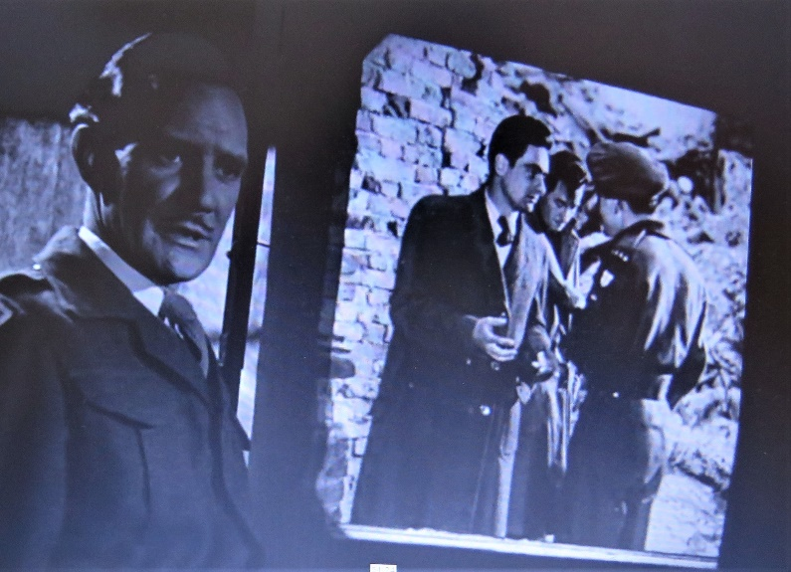
(Caption 3: Magic Lantern Slide Show. Light features prominently in this montage as Major Calloway lectures Holly Martin – but once again create a caption explaining its role in this important sequence.)

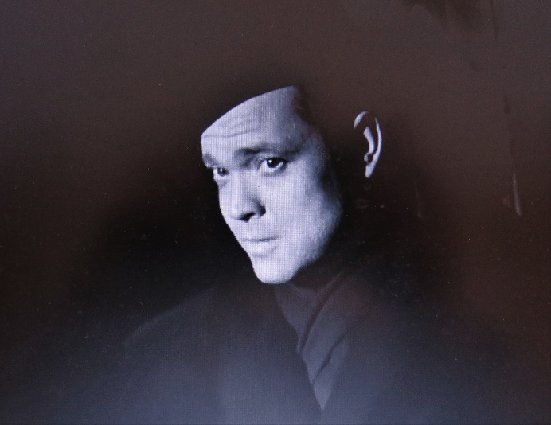
(Caption 4: We meet Harry Lime for the first time – what role does light play in this important and possibly most famous scene in the film? What is the light source? Does chance or something more deliberate govern the part light plays at this moment? Fate and chance are important themes in the film – so this is in an important consideration.)

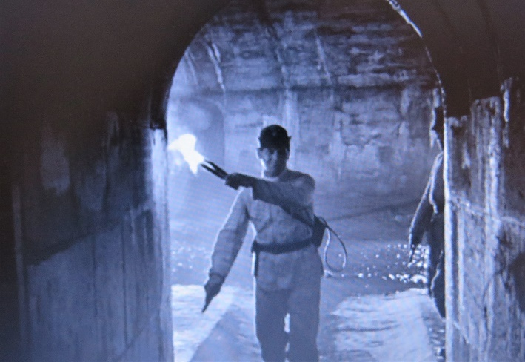
(Caption 5: The Pursuit. It is 1949 but they search for Harry in the sewers with burning torches. What associations does the use of naked flame here in the hunt create for you? Think how it makes the chase seem curiously old-fashioned. How does that contribute to the significance of the hunt?)

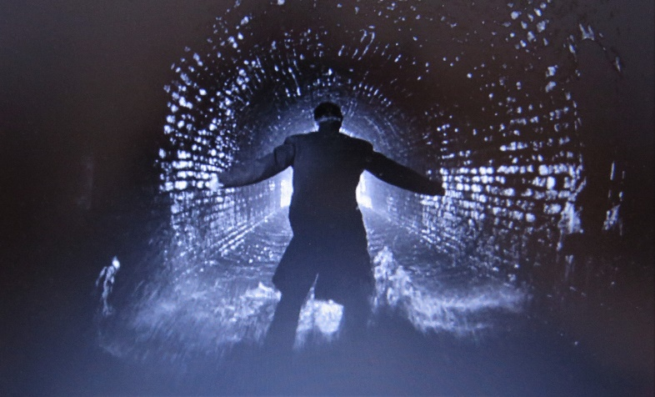
(Caption 6: Light and dark being used most profoundly in The Third Man – but your task is to explain this moment from the film with a caption that explores it’s possible symbolism.)

Activity 4 : All is Fortune
There is a strong element in The Third Man suggesting that it is fortune alone that governs human destiny. If true, it is a rather bleak outlook in which truth or morality don’t really figure. Instead it is just the arbitrary turning of the wheel of luck that determines who ends up on top or at the bottom. There is a helpful Wiki discussion of this theme at: Rota Fortunae - Wikipedia

The question is – do you agree that Fortune dominates events in The Third Man? To help your answer here are some stills from moments in the film when the motif crops up. The fact that Holly Martins walks under a ladder right at the start of the film is relevant here:

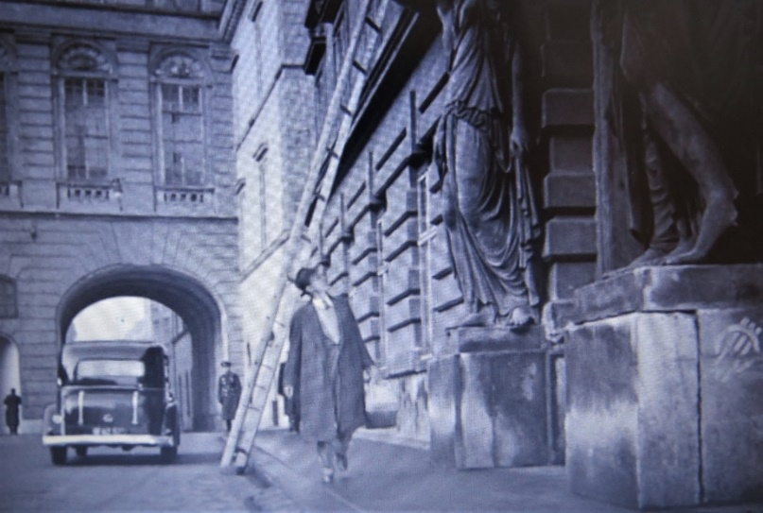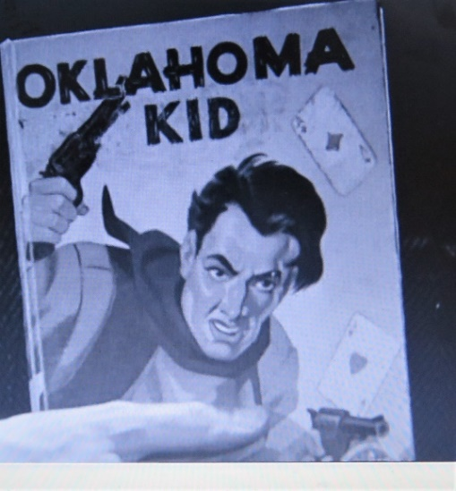
(Left) Holly’s fortune determined from the get go? (Right) The presence of playing cards on the cover of the novel Kurtz carries to identify himself.

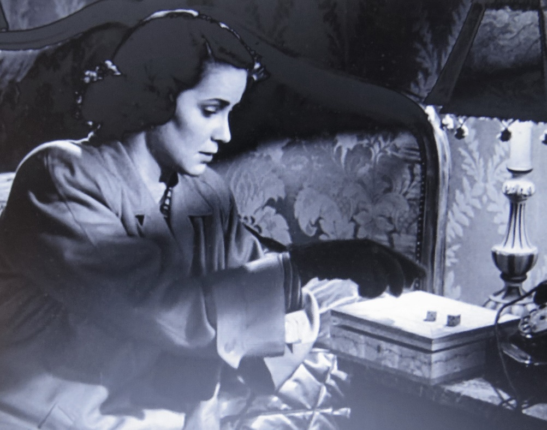
Anna goes automatically to the dice beside the bed she shared with Harry…

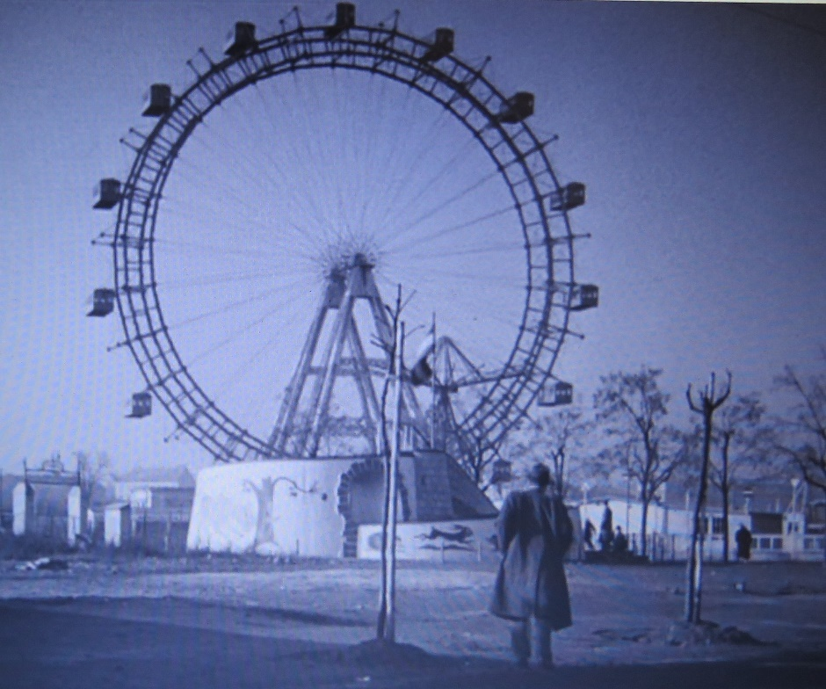
What goes up must come down?

Activity 5 : The Dots Don’t Matter?
Great films are full of patterns. Such patterns can be created by repeated or related actions/images/dialogue/music and colours. In this exercise, you are invited to study a series of incidents where a repeated shot comes to mean very different things and in doing so challenges the cynical views expressed by Harry Lime – views that might otherwise seem quite seductive.

Perhaps one of the most compelling moments in The Third Man comes when Harry Lime sets out his philosophy justifying his illicit sales in diluted penicillin to Holly Martins as they look down on the world from the top of the Prater Wheel. Is there anything in the film to challenge that cynical world-view? Can you find other moments in the film when that kind of bird’s eye shot or extreme high-angle has a very different meaning – one that challenges Lime’s ‘dots don’t matter’ outlook?

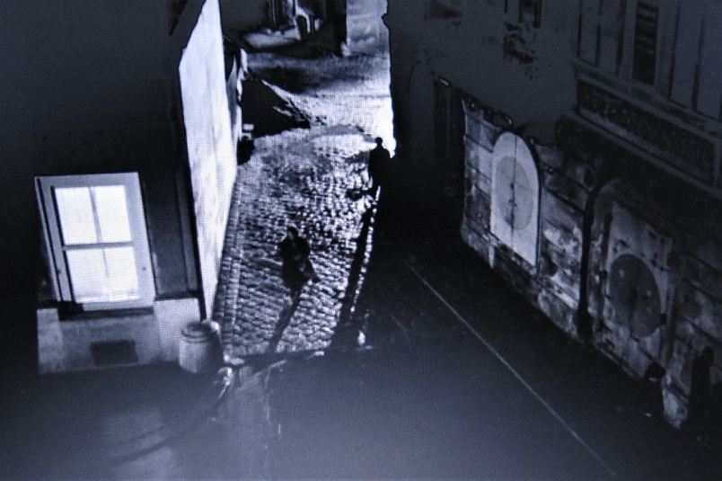
Karl the Porter’s high-angle view of the street below. The ‘dots’ he observed on the day of the accident will have profound meaning to all involved, not least him. (24.32 mins approx)

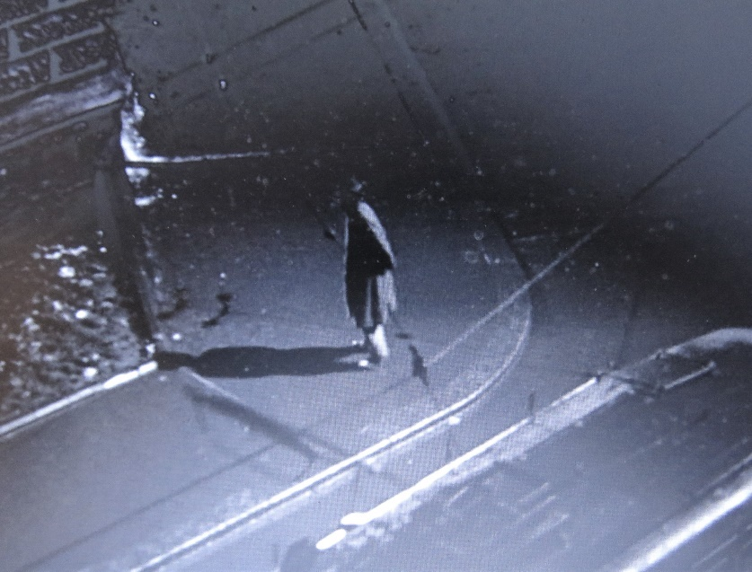
The point-of-view of Major Calloway and Anna as they look down on Holly Martins (approx 36.33mins)
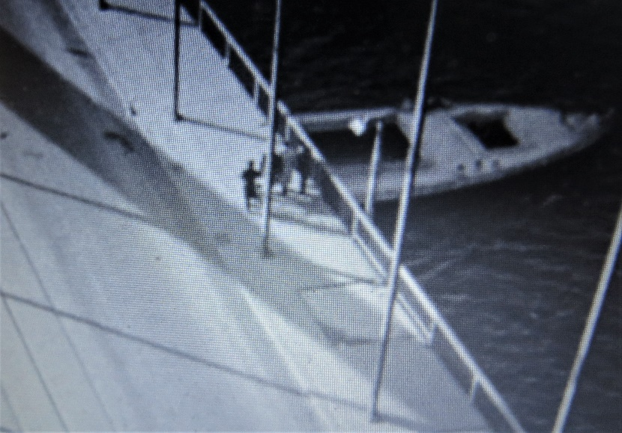
Harry Limes ‘friends’ gather on the Reichsbrucke (approx. 42.07 mins)
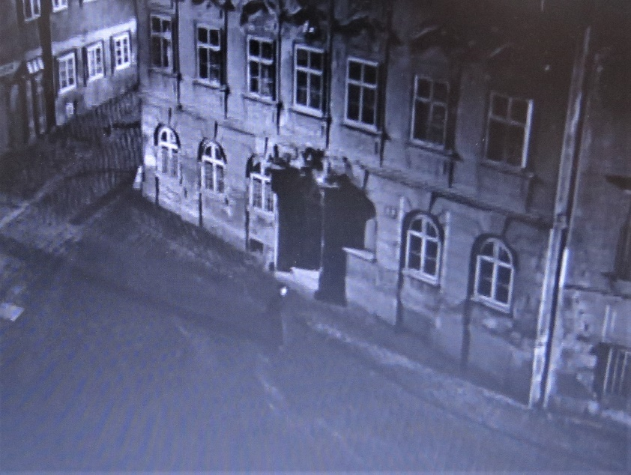
Harry as a ‘dot’ – approaching Anna’s apartment (approx. 1 hour 1.24 minutes)

Then there is this shot (approx. 57.41 mins), which occurs during the montage sequence when Calloway sets out the forensic case against Harry. Is there something here that forms a visual link and challenge to Harry’s god-like perspective on the world?

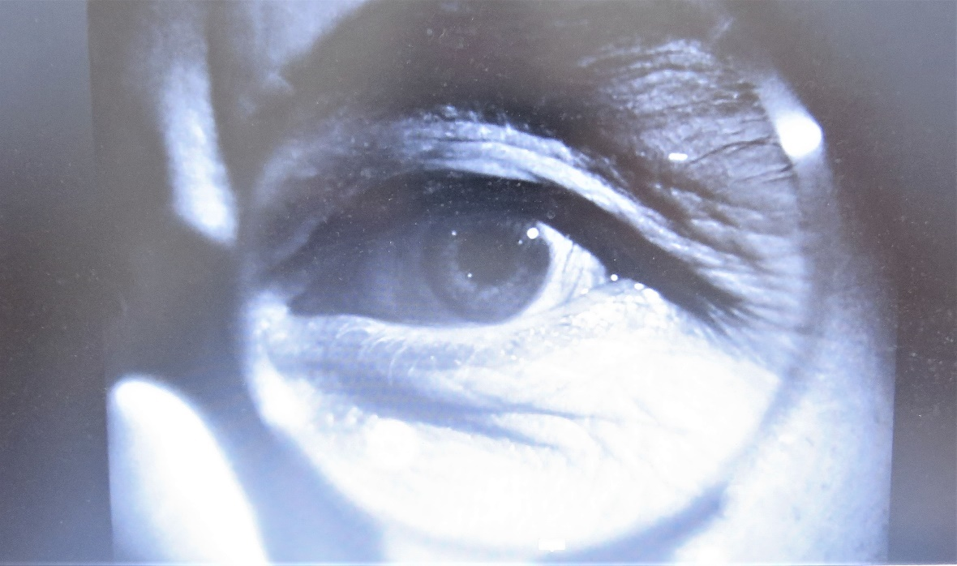

In what other ways does Calloway force Holly Martins to face the consequences of Lime’s crimes and the cynicism of his outlook about people’s inconsequentiality (unimportance)? Look again at the hospital scene in which Calloway forces Martins to see the impact on some of the dots of Limes adulterated penicillin. What makes the scene so impactful is perhaps its restraint? How does it suggest the suffering of the children without ever showing one of them?

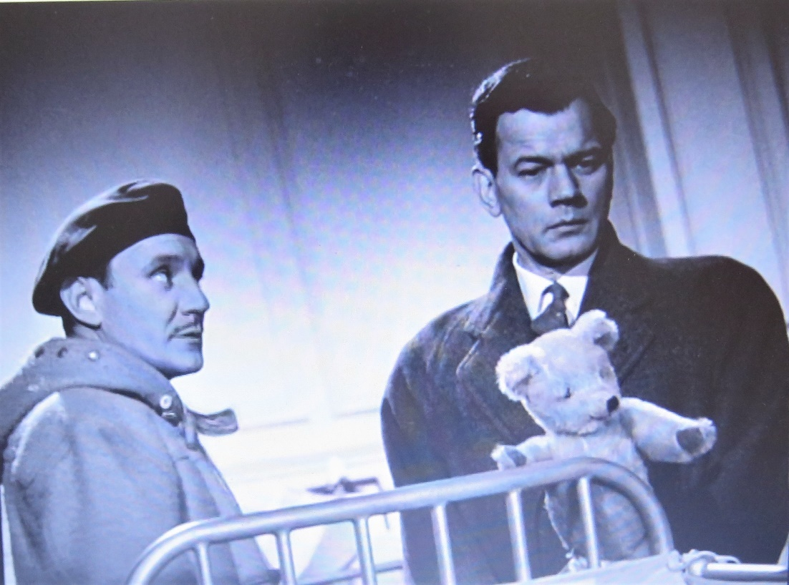
(Approx 1 hour 28.13)
Activity 6 : The Noir City
There are three chases and one frantic drive through the night-time streets of Vienna in The Third Man. Although we are told at the start that Vienna is similar to other European cities - ‘bombed about a bit’ – its eerily lit-streets and buildings play a central role in The Third Man. So too its inhabitants, often seen fleetingly in windows or doorways with faces often fearful or furtive.

The noir city is more often than not like the kind of maze people experience in anxiety dreams: a place of endless twists and turns, back-alleys and side streets, down which the heroes may drive or run, but can never shake off their pursuers

In 1887 the German sociologist Ferdinand Toennies suggested that two principal forms of social organization might come to predominate city environments. The first was a ‘gemeinschaft’ society based on a strong sense of community and face-to-face interaction. The other is the ‘gesellschaft’ city in which self-interest predominates and where money dominates interactions and social ties are superficial, contingent and exploitative. Which do you feel best applies to the Vienna of The Third Man?

What is your perception of the ordinary people of Vienna we see as occasional witnesses to the events of the film? An ideal way too assess this is to watch (and re-watch) the sequence when Holly thinks he’s been kidnapped. During the hair-raising taxi drive various people are seen in the shadows or staring from windows – but who are these people and what do you feel they are thinking/fearing? Here is one of the most suggestive faces we see during this sequence.

There is another dimension to the depiction of Vienna in The Third Man. Despite the rubble and the ruins, there is something fairytale and fantastic about the environment. (Think about the entrance to Harry Lime’s apartment as shown in still images illustrating the ladder and luck discussions earlier in this resource.) As you watch the film, see if you can spot examples of settings that might match these characteristics. (There will be more about this when we consider the depiction of Anna Schmidt in the film.

Activity 7 : The Danger of Innocence

Quote 1: Calloway: “I told you to go away, Martins. This isn’t Santa Fe. I’m not a sheriff and you aren’t a cowboy…”

Quote 2: Harry Lime: “What do you want me to do? Be reasonable. You didn’t expect me to give myself up….’it’s a far, far better thing that I do.’ The old limelight. The fall of the curtain. Oh, Holly, you and I aren’t heroes. The world doesn’t make any heroes outside of your stories.”

Critics often suggest that true noirs are not those films featuring resourceful private eyes or detectives who manage to penetrate the noir world, solve crimes and then emerge roughed-up but uncorrupted at the end. There are a number of famous examples of these kinds of films such as The Big Sleep, but their qualification as noirs depends rather on the gloomy world they depict rather than their heroes’ remarkable ability to remain unsullied while negotiating its darkest realms.

The word ‘resourceful’ does not really apply to Holly Martins. Consider the following and decide which you feel is his greatest limitation when it comes to successfully investigating what happened to Harry Lime. Try to put the list in order of descending seriousness: the greatest weakness first and so on.
- He speaks no German.
- He has no money – the army currency he is issued with seems to be useless in the kinds of places he needs to go to investigate Harry Lime’s fate.
- He falls hopelessly and unrequitedly in love with Anna, Harry’s lover.
- He is a very poor judge of character.
- He’s a drunk.
- He is incapable, it seems, of protecting those who do confide in him: the porter Karl’s death is entirely Holly’s fault.
- He is foolhardy and impetuous. His behaviour in the sewer directly leads to Sergeant Paine’s death
- He messes up Anna’s chances by making an appearance at the station just as she’s about to leave to a new life.
- He is over-trusting of his friend Harry – despite their previous history that often involved him taking the blame for Harry’s misdemeanours.

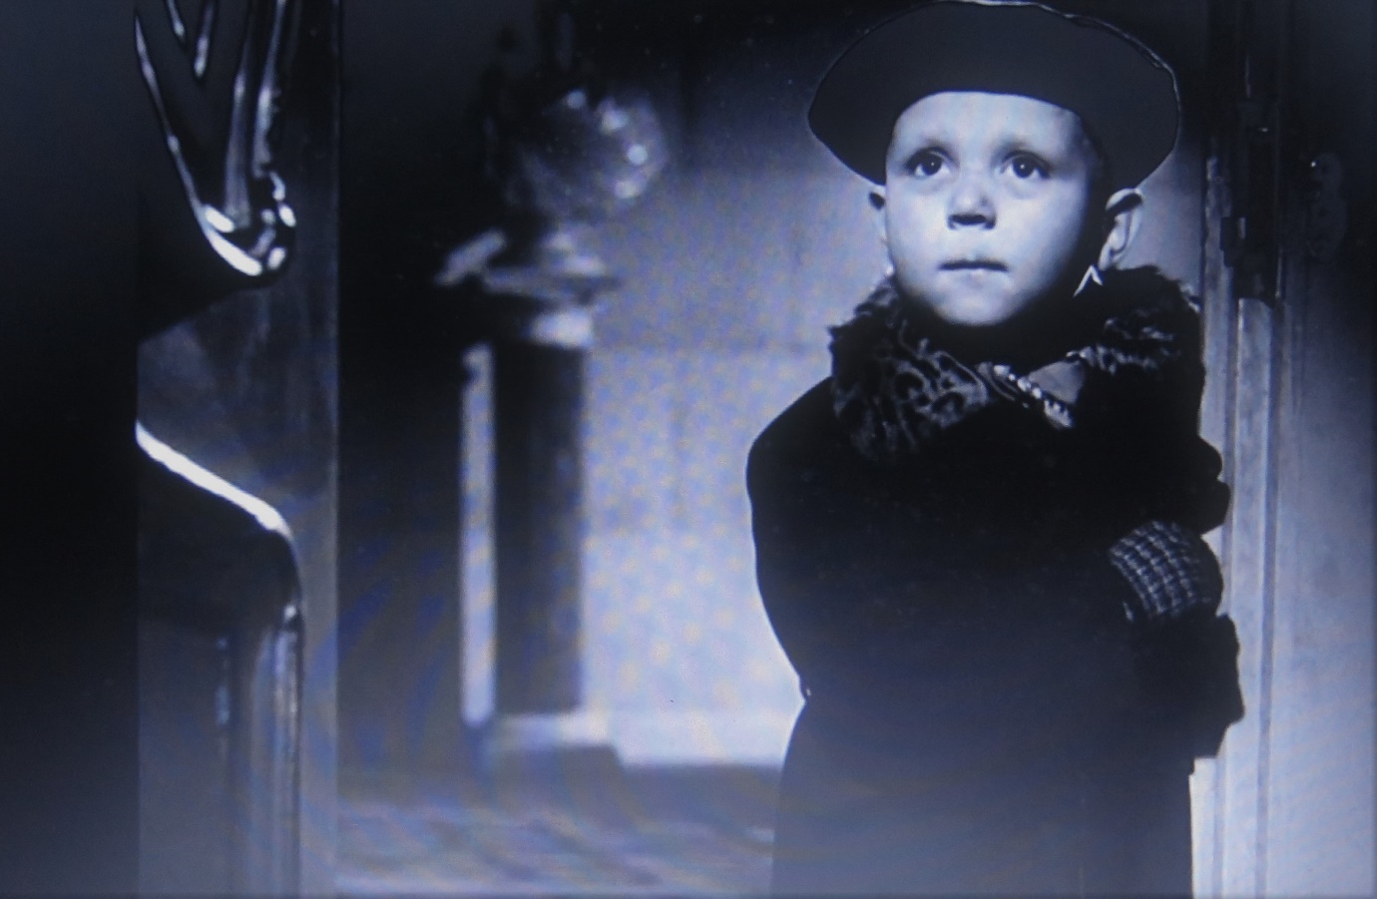

The still (25.27 minutes approx.) shows the little boy in Harry’s apartment block observing the argument between Holly and Karl the Porter. What, if any, connection can you find between Holly and his search for the truth, and the little boy’s perception of what he witnesses and the subsequent danger that springs from his child-like (‘innocent’?) perception of events. If there is a link – then it is not flattering.

And finally, consider the long chase sequence, that culminates in this shot of Harry reaching for the air – is there any sense in which an audience might come to pity him during his desperate final attempt to escape.

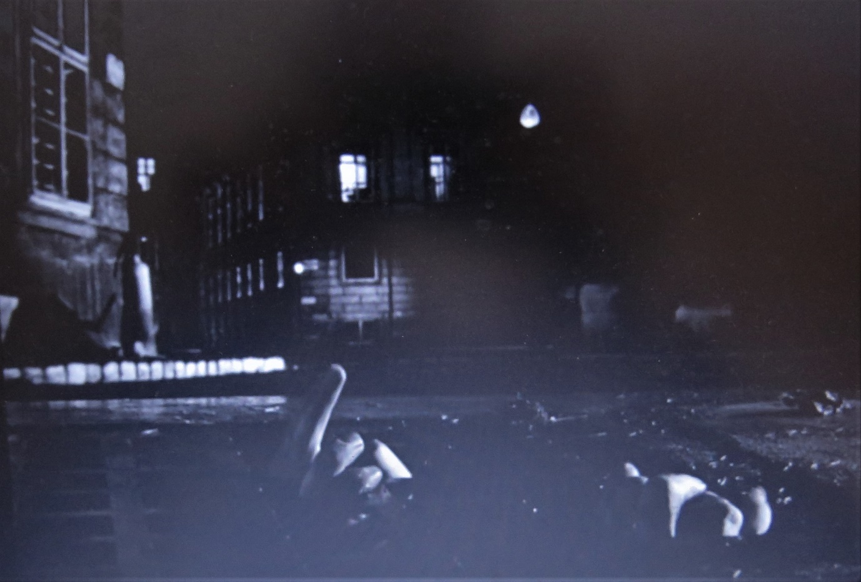

Activity 8 : The noir woman

Women in noirs are represented typically at either end of the moral spectrum. There are the ruthless femmes fatales: spider women who entice and entrap and ‘good girls’ who sometimes offer the hero a seeming way out, or at least a glimpse of what might have been even as fate cuts off all exits. Such women often fail in their desire to save the hero or crop up too late in the tale to change things, providing only an extra degree of poignancy to the sad proceedings.

But what do you feel about the depiction of Anna Schmidt in The Third Man – does she fit the stereotyped extremes of womankind offered in typical noirs?

- Consider her suicidal state of mind wishing only for death?
- Consider her devotion to Harry Lime, despite what he may have done – does that make her love almost pure, because it is so absolute? Or is she deluded and obsessive?
- The fact that she keeps calling Holly ‘Harry’ and is even seen in Harry’s monogramed silk pyjamas at one point.
- Consider her profession and the fairy-tale plays she performs in – only comedies, she explains.
- Consider her circumstances in a strange half-ruined, half-fairy tale mansion.
- Consider her betrayal by Harry over the passport – the very thing he acquired for her in the first place.
- Consider her passivity in the face of the authorities that seek to repatriate her to Communist controlled Czechoslovakia.
- Consider her refusal to participate in he plot against Harry or benefit from Holly’s deal with the authorities.
- Consider her protection of Holly throughout the film, especially in the café when Harry makes his entrance and realises the trap he’s stepped into.

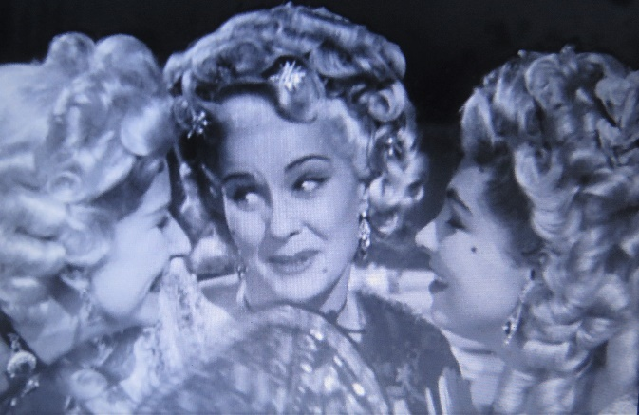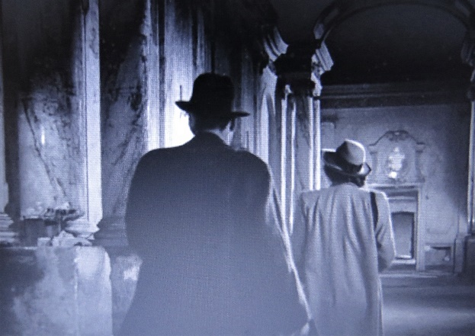

Activity 9 : Is The Third Man A Comedy?

Graham Greene called the story ‘an entertainment’ and your task is to identify when the film’s mood shifts to the absurd or darkly humorous. Film noirs are many things but they are rarely funny – so identifying such moments will help your analysis of The Third Man and challenge its ‘placement’ in a single genre box.

Things to look out for:
- Holly’s woeful attempt to provoke a bar-room brawl with Major Calloway.
- Holly’s failure to pronounce Dr Winkel’s name correctly
- Every scene involving Crabbin: the main in charge of cultural propaganda.
- Sergeant Paine’s dry comments.
- The parakeet incident and subsequent attempts by Holly to explain what happened.
- The opening slide joke at the start of the montage of evidence against Harry.
- Despite the very business-like arrest of Anna by the four-nations patrol, notice how it is the French soldier who ensures she leaves with her lipstick.

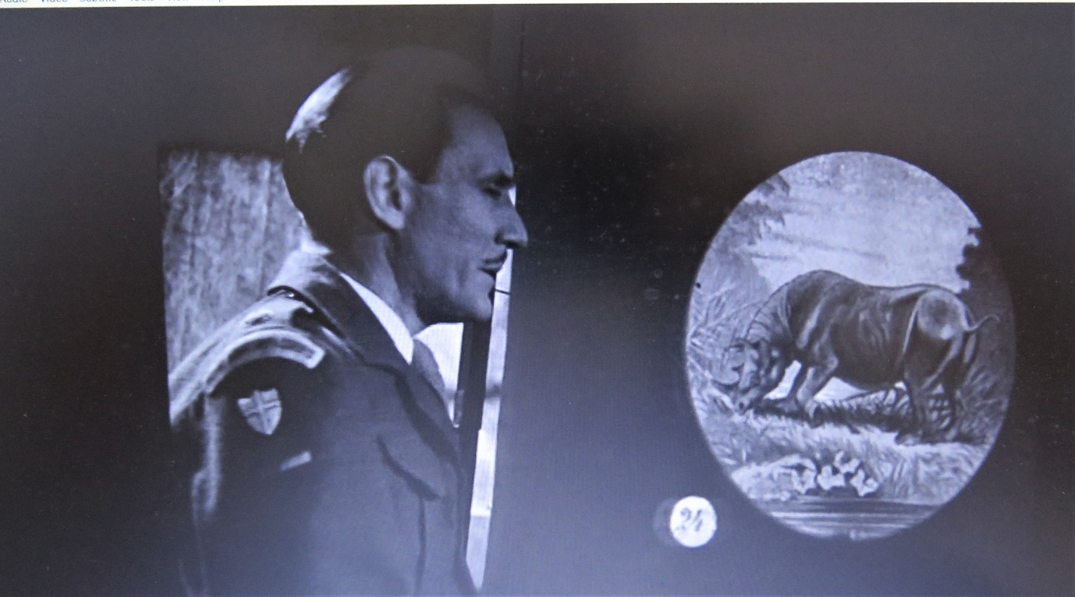

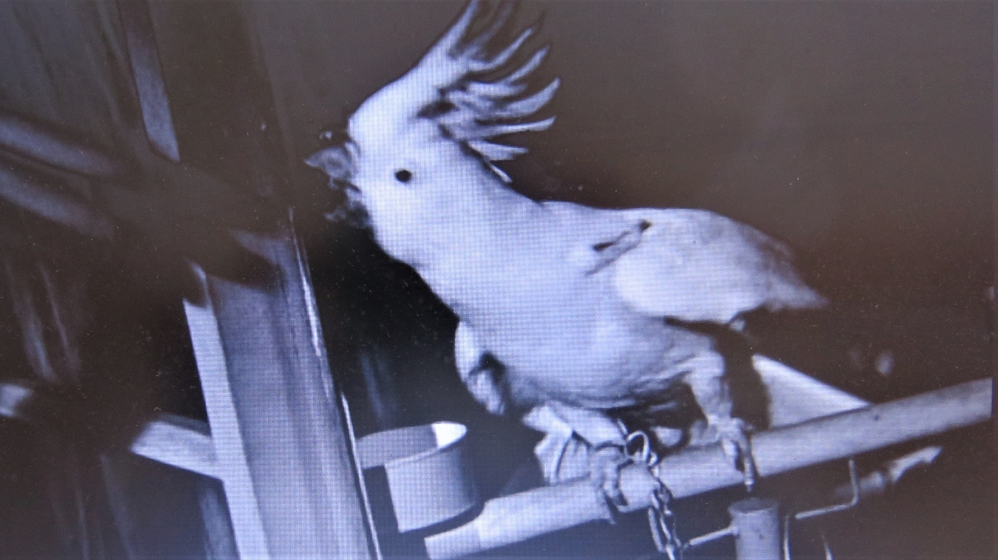

Activity 10: The Ending
Graham Greene’s novella's implies that Anna and Martins are about to begin a new life together: Calloway is narrating:
“I watched him striding off on his overgrown legs after the girl. He caught her up and they walked side by side. I don't think he said a word to her: it was like the end of a story except that before they turned out of my sight her hand was through his arm—which is how a story usually begins. He was a very bad shot and a very bad judge of character, but he had a way with Westerns (a trick of tension) and with girls (I wouldn't know what).”
Contrast this to the actual ending of the film. It is a protracted ending with Anna walking up the graveyard avenue while Holly waits for her to one side. Significantly, she is little more than a dot at the start of the sequence. What is your reaction to the ending? Do you think the director Carol Reed made the right decision?

